PROCESS FOR computing SAMPLE SIZE versus POWER by D (the Difference between the SE and SEF means) and alpha=0.1

TRIAL1

1) NCSS:
a) Cross-over analysis with T-tests.
- For SCORE
SE SCORE mean = 10.89
SEF SCORE mean= 19.72
Equivalence Interval = (EL, EU) = (-2.18, +2.18)

Equivalence Based on the Confidence Interval of the Difference
Lower Lower 90,0% Upper 90,0% Upper Equivalent
Equivalence Confidence Confidence Equivalence at the 5,0%
Test Type Limit Limit Limit Limit Sign. Level?
Shortest C.I. -2,17778 7,68774 9,97893 2,17778 No
Westlake C.I. -2,17778 -9,71047 9,71047 2,17778 No
Note: Westlake's k2 = -28,26 and k1 = 1,34.

The value 2.18 = 20% of the SCORE mean in SE.
So, 10.89 * 0.2 = +2.18, which is the upper equivalent limit (EU), and -2.18 is the lower (EL).

- For TIMESEC (in seconds):
SE TIMESEC mean = 376.44
SEF TIMESEC mean = 281.61
Equivalence Interval = (EL, EU) = (-75.29, +75.29)

Equivalence Based on the Confidence Interval of the Difference
Lower Lower 90,0% Upper 90,0% Upper Equivalent
Equivalence Confidence Confidence Equivalence at the 5,0%
Test Type Limit Limit Limit Limit Sign. Level?
Shortest C.I. -75,28889 -126,68183 -62,98484 75,28889 No
Westlake C.I. -75,28889 -119,21852 119,21852 75,28889 No
Note: Westlake's k2 = -1,34 and k1 = 11,73.

The value 75.29 = 20% of the TIMESEC mean in SE.
So, 376.44 * 0.2 = +75.29, which is the upper equivalent limit (EU), and -75.29 is the lower (EL).

b) Repeated measures analysis with ANOVA for computing the standard deviation as Sw.

- Sw: Specify the standard deviation S as the square root of the within mean square error from a repeated measures ANOVA. This is the most common method since cross-over designs are usually analyzed using ANOVA.

Sw = SQR(MSE) = SQR (the intersection of row BC(A) and column Mean Square of repeated measures ANOVA).

- For SCORE:
Sw = SQR (3.875) = 1.968501

- For TIMESEC:
Sw = SQR (2994.951) = 54.726145

2) PASS:

We run the module: “Equivalence Tests for Two Means in a 2x2 Cross-Over Design using Differences” with the previous data.

- For SCORE:
EU=+2.18, S=SQR (3.875)=1.968501 and D=0 0.5 1 points (the Difference between the means).

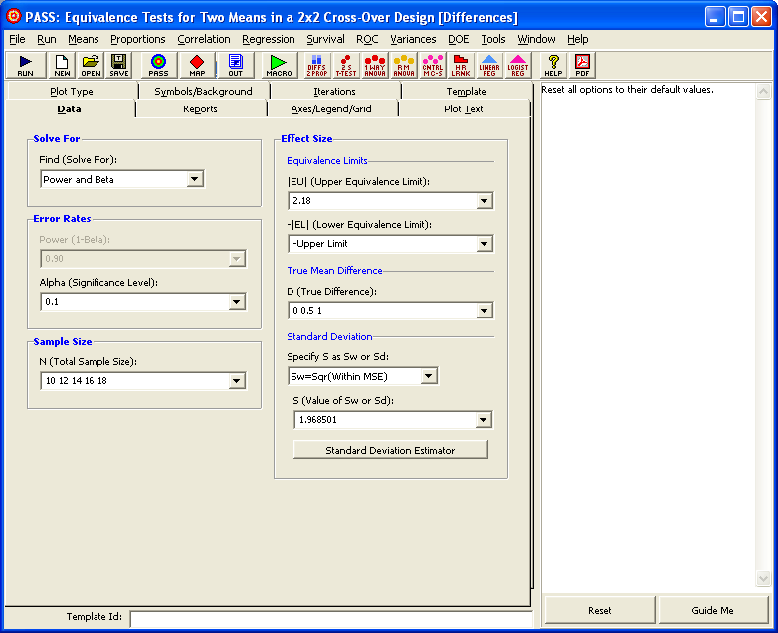

- For TIMESEC:
EU=+75.29, S=SQR (2994.951)=54.726145 and D= 0 10 20 30 seconds (the Difference between the means).

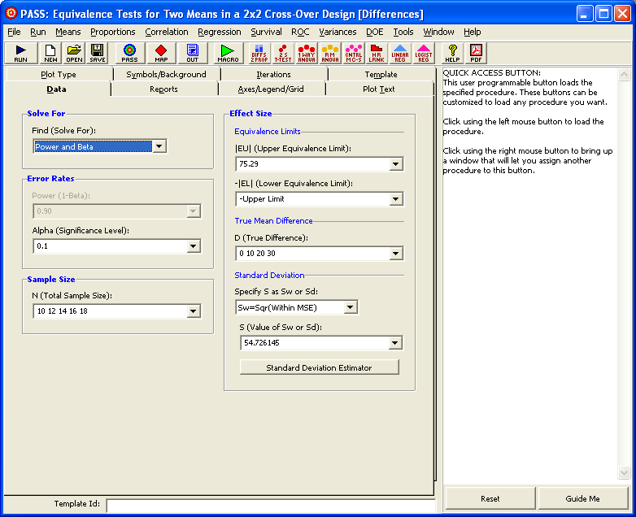

PROCESS FOR computing SAMPLE SIZE versus POWER by D (the Difference between the SE and SEF means) and alpha=0.1

TRIAL1X

1) NCSS:
a) Cross-over analysis with T-tests.
- For SCORE
SE SCORE mean = 12.15
SEF SCORE mean = 19.53
Equivalence Interval = (EL, EU) = (-2.43, +2.43)

Equivalence Based on the Confidence Interval of the Difference
Lower Lower 90,0% Upper 90,0% Upper Equivalent
Equivalence Confidence Confidence Equivalence at the 5,0%
Test Type Limit Limit Limit Limit Sign. Level?
Shortest C.I. -2,43036 5,23493 9,51507 2,43036 No
Westlake C.I. -2,43036 -9,00661 9,00661 2,43036 No
Note: Westlake's k2 = -13,56 and k1 = 1,35.

The value 2.43 = 20% of the SCORE mean in SE.
So, 12.15 * 0.2 = +2.43, which is the upper equivalent limit (EU), and -2.43 is the lower (EL).

- For TIMESEC (in seconds):
SE TIMESEC mean = 358.53
SEF TIMESEC mean = 289.00
Equivalence Interval = (EL, EU) = (-71.71, +71.71)

Equivalence Based on the Confidence Interval of the Difference
Lower Lower 90,0% Upper 90,0% Upper Equivalent
Equivalence Confidence Confidence Equivalence at the 5,0%
Test Type Limit Limit Limit Limit Sign. Level?
Shortest C.I. -71,70536 -107,50658 -31,54699 71,70536 No
Westlake C.I. -71,70536 -98,48302 98,48302 71,70536 No
Note: Westlake's k2 = -1,35 and k1 = 7,83.

The value 71.71 = 20% of the TIMESEC mean in SE.
So, 358.53 * 0.2 = +71.71, which is the upper equivalent limit (EU), and -71.71 is the lower (EL).

b) Repeated measures analysis with ANOVA for computing the standard deviation as Sw.

- For SCORE:
Sw = SQR (10.90385) = 3.3020

- For TIMESEC:
Sw = SQR (3434.215) = 58.602175

2) PASS:

- For SCORE:
EU=+2.43, S=SQR (10.90385)=3.3020 and D=0 0.5 1 points (the Difference between the means).

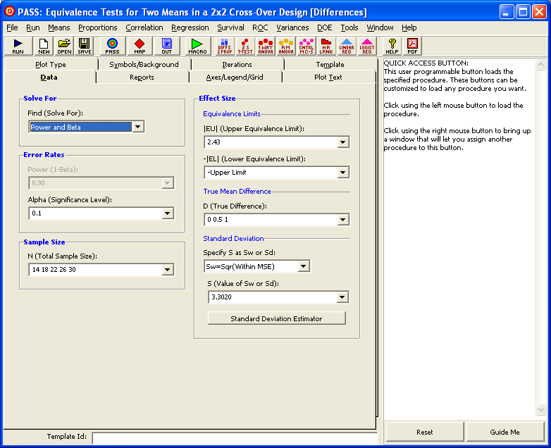

- For TIMESEC:
EU=+71.71, S=SQR (3434.215)=58.602175 and D= 0 10 20 30 seconds (the Difference between the means).

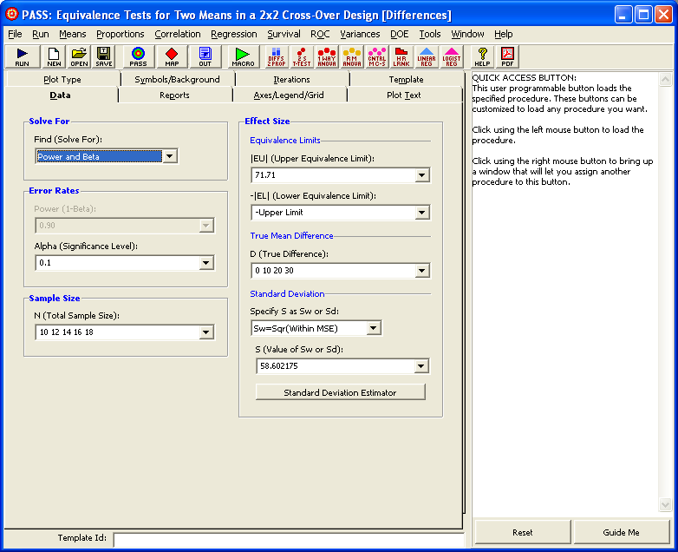

PROCESS FOR computing SAMPLE SIZE versus POWER by D (the Difference between the SE and SEF means) and alpha=0.1

TRIAL2

1) NCSS:
a) Cross-over analysis with T-tests.
- For SCORE
SE SCORE mean = 5.56
SEF SCORE mean= 10.06
Equivalence Interval = (EL, EU) = (-1.11, +1.11)

Equivalence Based on the Confidence Interval of the Difference
Lower Lower 90,0% Upper 90,0% Upper Equivalent
Equivalence Confidence Confidence Equivalence at the 5,0%
Test Type Limit Limit Limit Limit Sign. Level?
Shortest C.I. -1,11250 3,15821 5,84179 1,11250 No
Westlake C.I. -1,11250 -5,52466 5,52466 1,11250 No
Note: Westlake's k2 = -13,16 and k1 = 1,35.

The value 1.11 = 20% of the SCORE mean in SE.
So, 5.56 * 0.2 = +1.11, which is the upper equivalent limit (EU), and -1.11 is the lower (EL).

- For TIMESEC (in seconds):
SE TIMESEC mean = 1643.94
SEF TIMESEC mean = 1399.06
Equivalence Interval = (EL, EU) = (-328.79, +328.79)

Equivalence Based on the Confidence Interval of the Difference
Lower Lower 90,0% Upper 90,0% Upper Equivalent
Equivalence Confidence Confidence Equivalence at the 5,0%
Test Type Limit Limit Limit Limit Sign. Level?
Shortest C.I. -328,78750 -406,38844 -83,36156 328,78750 No
Westlake C.I. -328,78750 -368,21829 368,21829 328,78750 No
Note: Westlake's k2 = -1,35 and k1 = 6,69.

The value 328.79 = 20% of the TIMESEC mean in SE.
So, 1643.94 * 0.2 = +328.79, which is the upper equivalent limit (EU), and -328.79 is the lower (EL).

b) Repeated measures analysis with ANOVA for computing the standard deviation as Sw.

- For SCORE:
Sw = SQR (4.642857) = 2.154728

- For TIMESEC:
Sw = SQR (67272.2) = 259.368849

2) PASS:

- For SCORE:
EU=+1.11, S=SQR (4.642857)=2.154728 and D=0 0.5 1 points (the Difference between the means).

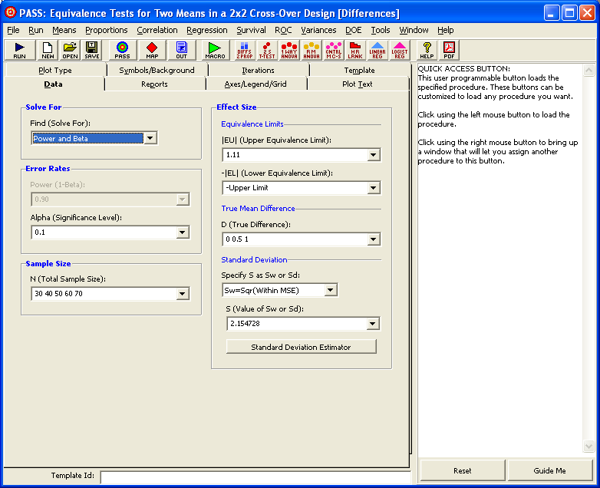

- For TIMESEC:
EU=+328.79, S=SQR (67272.2)=259.368849 and D= 0 10 20 30 seconds (the Diffe-rence between the means).

